

Established under sub section (3) of Section 1 of Garden City University Act, 2013 (Karnataka Act No. 47 of 2013)

Dr. A P J Abdul Kalam School of Engineering

B.Tech in Computer Science and Engineering (AI & ML, CS and DS)

Web Designing Project Report



Project Title: Job Finder

Submitted by

NAME : Allu Hima Priya

REGISTER NUMBER : 22BTAI147

SECTION : A

Teammates Names : Kusuma Priya .S (22BTAI140)

Sadhana .S .P (22BTAI156)

COURSE CODE: 10ABTEC22215 COURSE INSTRUCTOR: Mrs.Chinta Indira Devi

COURSE NAME: Web Designing SEMESTER: II

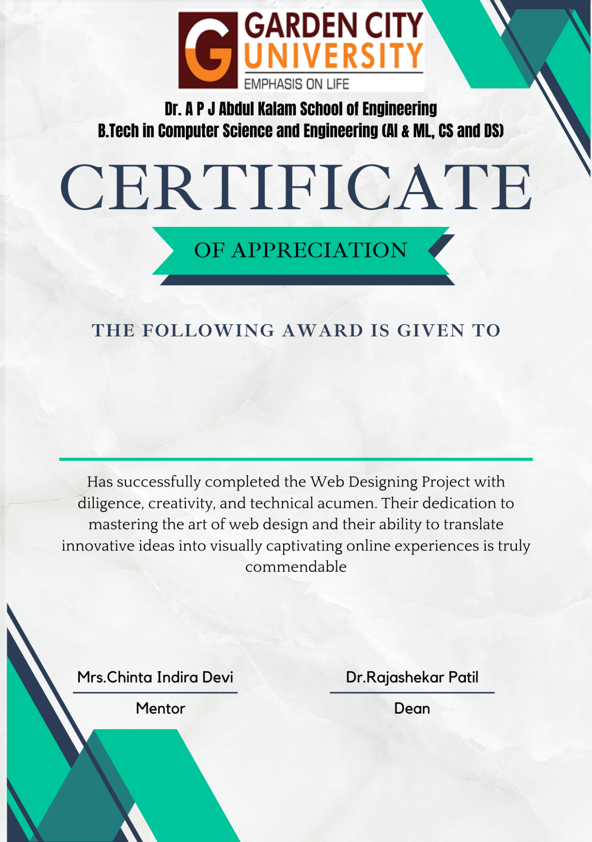

Acknowledgement

I would like to express my sincere gratitude for the remarkable opportunity to create this website. I extent my warmest appreciation to Prof. Indira Devi Ma’am for entrusting me with this project. Your unwavering support, encouragement and valuable guidance have been instrumental in making this endeavour a success. This experience has been a profound learning journey, allowing me to enhance my skills and gain valuable insights and knowledge into web development and web designing.

I would also wish to acknowledge the collaborative efforts of my team and all those who provided valuable input and feedback. Their unwavering commitment and their relentless pursuit of innovation have been the driving force behind this website. I extend my heartfelt gratitude to all those who contributed to its realization.

Description of project

# Job Finder - Your Gateway to Employment Opportunities

Welcome to Job Finder, the ultimate destination for job seekers and employers alike. We are a cutting-edge online platform dedicated to connecting talented individuals with their dream careers while assisting employers in finding the perfect candidates for their organizations.

For Job Seekers:

Our user-friendly interface empowers job seekers to navigate through a vast array of industries, positions, and locations effortlessly. Whether you're a recent graduate or an experienced professional looking for a career change, JobFinder.com provides a comprehensive database of job listings tailored to your unique qualifications and preferences. Our advanced search filters and AI-driven matching algorithms ensure that you discover the most relevant job opportunities that align with your skillset and aspirations.

For Employers:

At Job Finder, we understand the significance of hiring the right talent to drive your business forward. Our platform offers a seamless recruitment process, enabling employers to post job openings, screen applications, and assess candidates with ease. By utilizing our intelligent candidate matching system, employers can swiftly identify top-tier individuals who possess the necessary expertise and cultural fit, streamlining the hiring process and saving valuable time.

We take pride in fostering meaningful connections between job seekers and employers, contributing to the growth and success of businesses while empowering individuals to embark on rewarding career journeys. Join Job Finder today and unlock a world of opportunities!

Screenshots of each page of the website with brief description down about that page

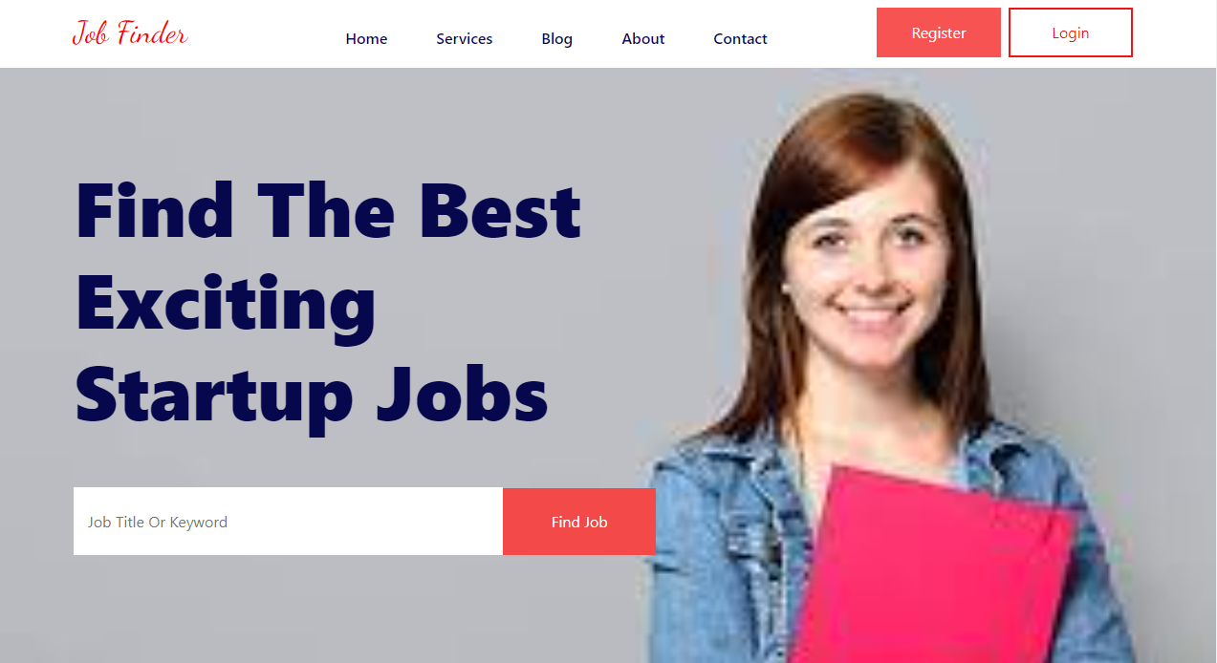

Welcome to Job Finder - your ultimate destination for finding the perfect job! On our homepage, you'll experience a user-friendly interface designed to make job hunting a breeze. Discover a wide range of career opportunities across various industries, and let us guide you towards your dream job.

* Home - Here, you'll find a powerful job search engine that allows you to filter through thousands of job postings based on your preferences. Whether you're looking for entry-level positions, remote work opportunities, or executive-level roles, Job Finder has it all.
* Services - We offer personalized assistance, including resume building, interview coaching, and career counselling. Our goal is to empower you with the tools and knowledge needed to stand out in the competitive job market.
* Blog - Where you'll find insightful articles on job search tips, career development, and industry trends. Our team of experts is committed to providing valuable information to help you stay ahead in your professional journey.
* About us - We are dedicated to transforming the job search experience for both job seekers and employers. Our mission is to connect talented individuals with their dream job opportunities while helping businesses find the perfect fit for their team. With a commitment to excellence and innovation, we have created a seamless, user-friendly platform that empowers you to take charge of your career journey.
* Contact - Your direct line of communication with our dedicated support team. Whether you have questions about our services, need technical assistance, or want to share your experience, our team is ready to listen and provide prompt and helpful responses.
* Register - Click on the "Register" button prominently displayed on our homepage. Fill in your details, including your name, email address, and a secure password. Confirm your registration through a verification email, and voilà! You're now a valued member of our vibrant Job Finder community.
* Login - Logging in to your account allows you to continue your job search journey seamlessly and take advantage of our personalized services.

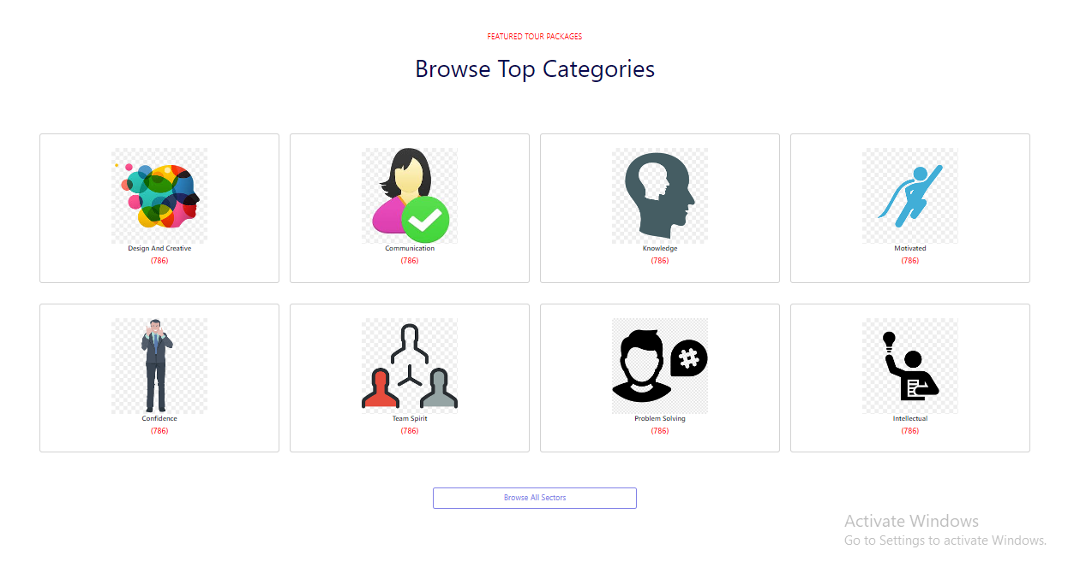

Discover Your Dream Career - Browse Top Categories Now!

Explore a wide range of job categories tailored to your interests and expertise. Click to browse and uncover the perfect career opportunities that match your passion.



Our Online Resume feature is designed to empower job seekers to stand out in the competitive job market. With this powerful tool, you can create a professional and visually appealing CV that highlights your skills, accomplishments, and experiences. Say goodbye to traditional paper resumes and embrace the future of job applications with our user-friendly and accessible Online Resume.

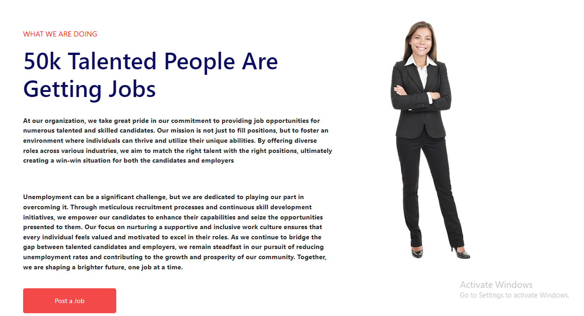

This section of the page gives the information about our Job Finder Community which is a vibrant and inclusive space that brings job seekers and employers together. It's a hub of networking, knowledge-sharing, and career growth, designed to support talented people throughout their professional journey. Provided with “Post a Job” button to help discover exciting jobs of their desired field.

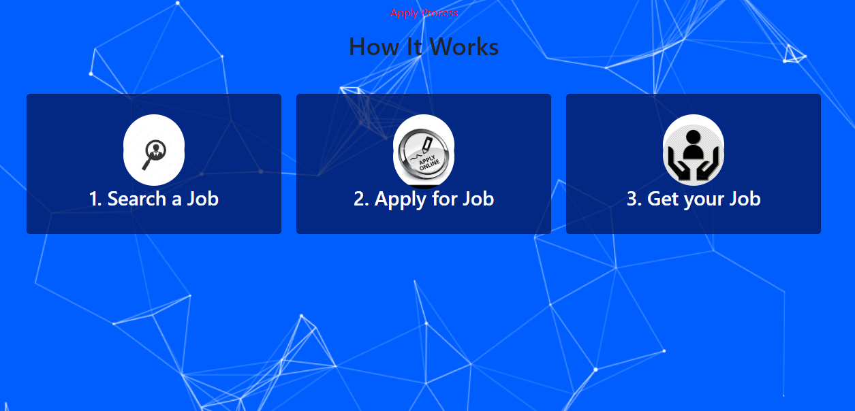

The above section of our website provides the information about how the process takes place before getting a desired job.

1. Search a job: Explore our vast database of job listings by browsing through different categories, industries, and locations. You can also use our advanced search filters to refine your results based on your preferences.
2. Apply for Job: Once you find a job that aligns with your aspirations, qualifications, and interests, submit your application directly through our platform. You can upload your resume and cover letter to showcase your suitability for the role.
3. Get your Job: Impress potential employers during the interview process, and if all goes well, you might receive a job offer! Negotiate the terms and conditions, and when you're satisfied, accept the offer to begin your new career journey.

Our website is the result of a collaborative effort by a talented team of creators and co-partners who share a common vision to build a platform that revolutionizes the way job seekers connect with employers and find their dream careers.

Meet the Creators and Co-partners:

  

Our team of skilled members are the architects behind this cutting-edge job finder platform. With our knowledge and creativity in web development, we have crafted an intuitive and user-friendly website that ensures a seamless job search experience for every user.

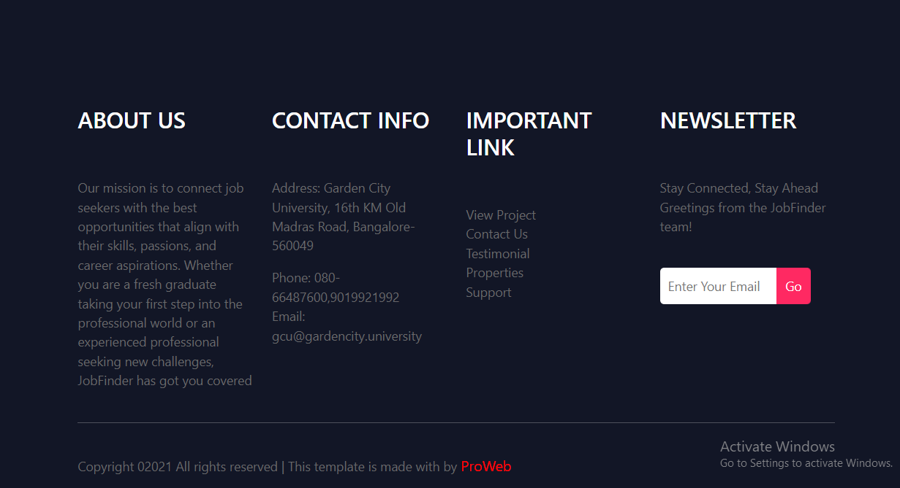

The last page of our website provides the overall information required to reach us out by providing the contact info, important links followed by newsletter.

* About us - At our website, we are passionate about empowering individuals in their journey to find the perfect career opportunities. Our mission is to connect talented job seekers with employers who are actively seeking their skills and expertise. With a user-friendly interface, cutting-edge technology, and personalized support, we aim to make the job search process seamless and rewarding.
* Contact Info - If you have any questions, feedback, or need assistance, our dedicated customer support team is here to help.

You can reach us via:

Email: [gcu@gardencity.university](mailto:gcu@gardencity.university)

Phone: 080-66487600,9019921992

Address: Garden City University,16th KM Old Madras Road, Bangalore-560049.

* Newsletter-Subscribing to our newsletter enables to stay up-to-date with the latest job opportunities, career resources, and platform updates. By subscribing, job seekers will receive valuable insights delivered straight to their inbox, ensuring them that they never miss an exciting career opportunity.

Future Scope

The future of the Job Finder Website holds immense potential and exciting opportunities for job seekers and employers alike. As technology continues to advance and the job market evolves, our platform is committed to staying at the forefront of innovation to meet the changing needs of the workforce. Here are some of the key areas where we envision the future scope of the Job Finder Website:

1. AI-Driven Job Matching.
2. Skill Mapping and Talent Analytics.
3. Virtual Career Fairs and Events.
4. Enhanced Employer Branding.
5. Remote Work and Gig Opportunities.
6. Integration of Emerging Technologies.
7. Continuous Career Development.
8. AI-Powered Resume Review.

At Job Finder, we are committed to evolving with the job market landscape, embracing innovation, and providing cutting-edge solutions to meet the ever-changing needs of job seekers and employers. The possibilities are boundless, and the future is bright for everyone involved in the Job Finder communit

Bibliography

Name of the website: Job Finder.

Created by: Kusuma Priya. S, Allu Hima Priya, Sadhana.S.P.

References: YouTube, Bootstrap, ChatGPT, Images from Google.

Created During: 01/07/23 to 07/08/23.

Vision: Our vision is to be the catalyst that empowers individuals to discover their true potential and find fulfilling career opportunities that align with their passions and aspirations. We strive to revolutionize the job search experience, leveraging innovative technologies and a user-centric approach to connect job seekers with employers seamlessly. Our ultimate goal is to enrich lives by fostering meaningful connections and driving professional growth for every member of our community. Together, we envision a world where talent meets opportunity, creating a brighter future for all.

Guided by: Prof.Indira Devi Ma’am

AI RESUME GENERATOR :

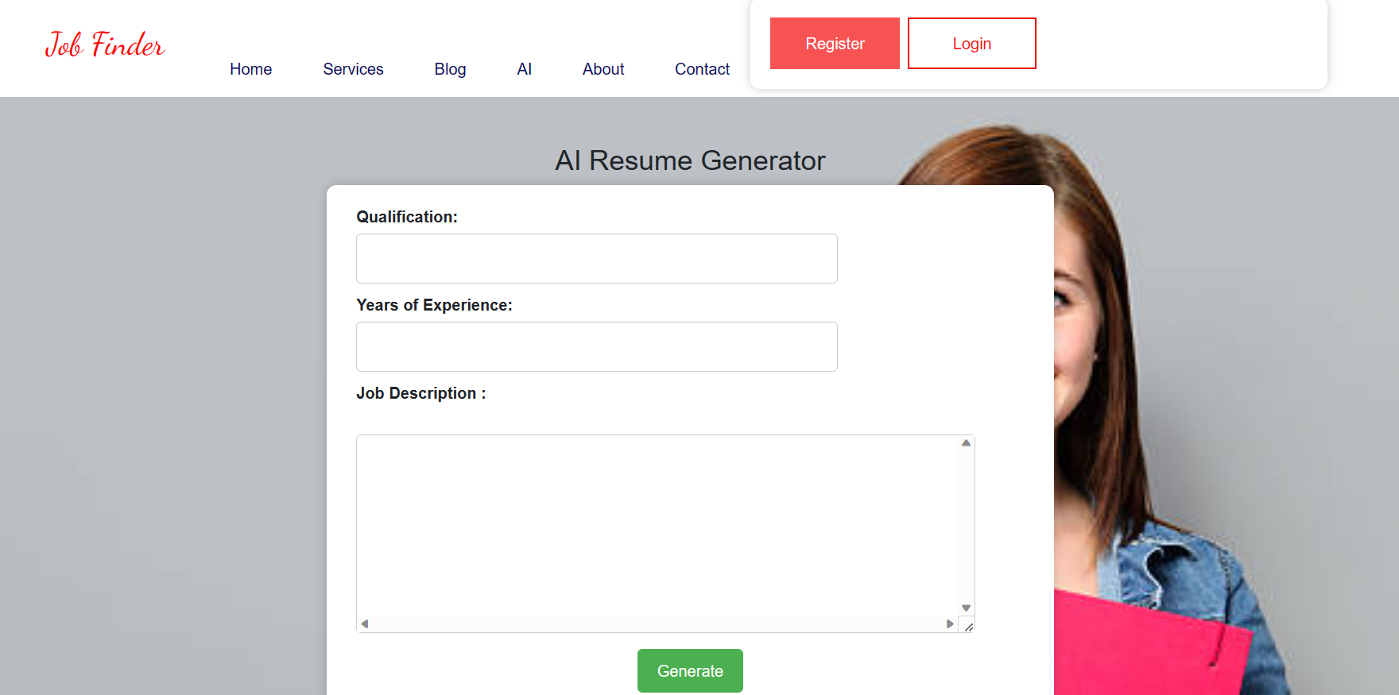

The AI-powered resume generator in a job finder platform is a sophisticated tool designed to assist job seekers in creating compelling and tailored resumes to enhance their chances of securing interviews and job offers. This tool leverages advanced natural language processing (NLP) and machine learning algorithms to analyse the user's input, job history, skills, and preferences to generate a highly customized and professional resume.

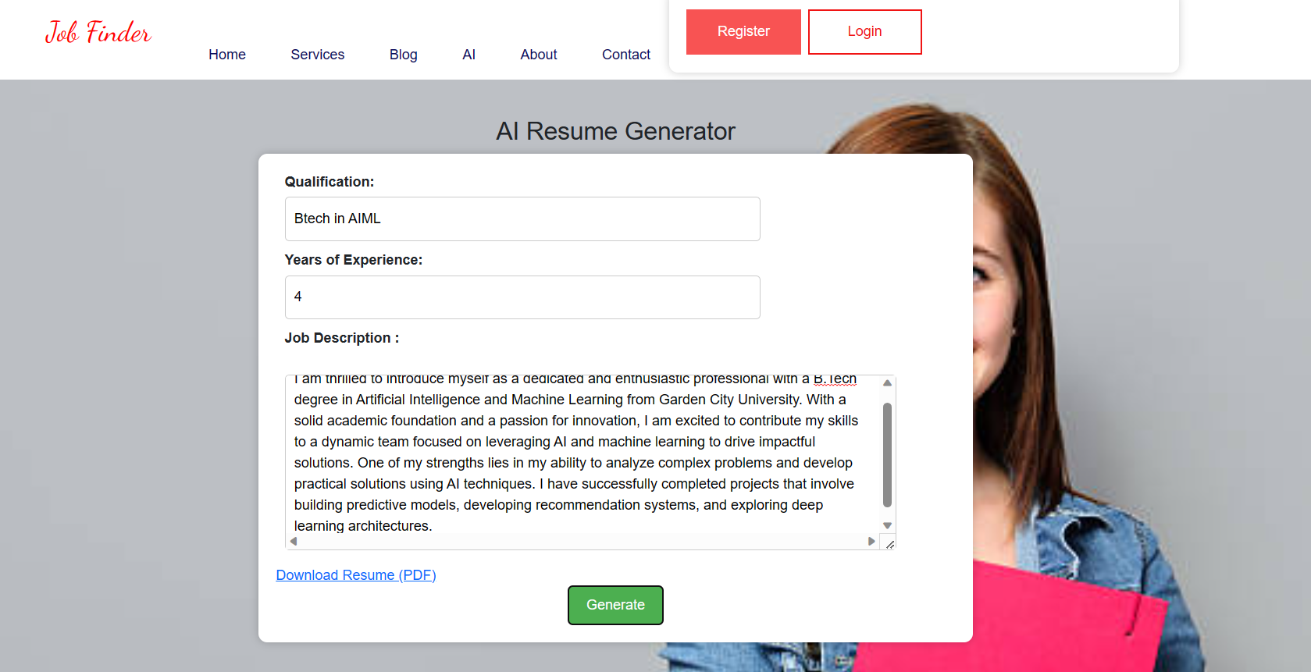

Sample Resume Generated by AI:

